
LOW LEVEL DESIGN
Azure Virtual Desktop — Build & Configuration Specification

AVD — CQC VENDOR SECURE ACCESS
Low Level Design — build and configuration specification

Document Reference: | LLD-AVD-CQC-001
Version: | 0.1 — DRAFT
Classification: | OFFICIAL — Internal / Confidential
Date: | 16 July 2026
Technical Author: | [Name, Title]
Organisation / Department: | Care Quality Commission — Technology & Digital
Cloud Region (Primary): | UK South
Cloud Region (Secondary): | UK West
Cloud Subscription: | [Subscription Name / ID]

Table of Contents
Table of Contents 2
1. Introduction 4
1.1 Document Purpose 4
1.2 Document Scope 4
1.3 Relationship to High Level Design 4
1.4 Assumptions, Dependencies and Constraints 4
2. Document Information 5
2.1 Version History 5
2.2 Reviewers and Approvers 5
2.3 Related Documents 5
3. Solution Component Design 5
3.1 Component Inventory 5
3.2 Detailed Component Specifications 6
4. Resource Organisation and Naming 7
4.1 Subscription, Resource Group and Naming Convention 8
4.2 Tagging Schema 8
5. Network Design Detail 8
5.1 IP Address Allocation Plan 8
5.2 Subnet and NSG Rule Detail 9
5.3 Route Tables (UDRs) 10
5.4 DNS and Private Endpoint Detail 10
6. Identity, Access and Security Configuration 10
6.1 RBAC Role Assignments 11
6.2 Managed Identity Configuration 11
6.3 Conditional Access Policy Detail 11
6.4 Key Vault, Secrets and Certificate Configuration 12
7. Data Design Detail 12
7.1 Data Access and In-Session Flow 12
7.2 Storage and Profile Definitions 13
7.3 FSLogix Profile Container Configuration 14
7.4 Data Retention, Archival and Purge Jobs 14
8. Integration and API Design Detail 14
8.1 Database Connection Specification 14
8.2 AVD Control-Plane Egress Endpoints (Firewall Allow-List) 14
8.3 Database Authentication Detail 15
9. Infrastructure as Code and Deployment 15
9.1 IaC Repository and Module Structure 15
9.2 Environment Parameter Matrix 15
9.3 CI/CD Pipeline Design 16
9.4 Deployment Sequence 16
10. Configuration Management 16
10.1 Host Pool RDP Properties (Device Redirection Lockdown) 16
10.2 Session Host Security Features 17
10.3 Scaling and Autoscale Rule Configuration 17
11. Monitoring, Logging and Alerting Detail 17
11.1 Metrics and Diagnostic Settings 17
11.2 Alert Rule Definitions 18
11.3 Dashboards and Workbooks 18
12. Testing and Validation 18
12.1 Test Strategy 18
12.2 Test Case Summary 18
12.3 Performance and Load Test Targets 19
12.4 DR / Failover Test Plan 19
13. Operational Runbooks 19
13.1 Deployment Runbook 19
13.2 Rollback Procedure 20
13.3 Scaling Procedure 20
13.4 Incident Response and Troubleshooting 20
14. Open Issues and Decisions 20
Appendix A -- Configuration and Script Reference 21
Appendix B -- Glossary 21
Appendix C -- Reference Architecture Links 22

Note: After opening this document in Microsoft Word, right-click the Table of Contents and select 'Update Field' to populate page numbers.

1. Introduction
This Low Level Design (LLD) provides the detailed technical specification required to build, configure and deploy the Azure Virtual Desktop (AVD) secure vendor-access solution for the Care Quality Commission (CQC). It translates the approved High Level Design (HLD-AVD-CQC-001) into implementation-ready detail: exact resource names and SKUs, IP addressing and NSG/route rules, Conditional Access policy definitions, session-host build and lockdown configuration, private database connectivity, Infrastructure-as-Code structure, and deployment and operational runbooks.

Scope: This document covers detailed component configuration, network and IP addressing, RBAC and Conditional Access detail, session-host and FSLogix configuration, database connectivity, Infrastructure-as-Code structure, deployment runbooks and test plans for the AVD vendor-access solution. It assumes the architecture and service selection in HLD-AVD-CQC-001 have been approved.

1.1 Document Purpose
The purpose of this document is to:

- Provide build-ready configuration for every AVD component identified in the HLD
- Define exact IP addressing, NSG rules, route tables and DNS for the AVD spoke
- Specify RBAC assignments, Conditional Access policies and Key Vault configuration
- Define FSLogix, session-host lockdown and database connectivity detail
- Provide deployment, rollback and operational runbooks for the delivery and operations teams

1.2 Document Scope
This LLD covers the build and configuration of the AVD vendor-access solution. The following are in and out of scope:

- In Scope: AVD host pool and session-host configuration, network addressing and rules, RBAC and Conditional Access, FSLogix, database connectivity, IaC modules, deployment runbooks and test plans
- Out of Scope: architecture decisions approved in the HLD, changes to the source databases, vendor-side device build, and licence procurement

1.3 Relationship to High Level Design
HLD Reference | HLD-AVD-CQC-001
HLD Approval Status | [Approved / Pending — date]
Architecture Changes Since HLD | None — this LLD implements the approved HLD without deviation
Traceability | Each LLD section maps to the corresponding HLD section; any deviation is logged in Section 14 (Open Issues and Decisions)

1.4 Assumptions, Dependencies and Constraints
Assumption 1 | The CQC Azure landing zone (hub, connectivity, policy baseline) is provisioned and available
Assumption 2 | HLD architecture and service selections are approved and will not change
Dependency 1 | Hybrid connectivity (ExpressRoute / VPN) to on-premises databases is live where those databases are in scope
Dependency 2 | Each vendor's static public egress IP ranges are confirmed for the Trusted Vendor IPs named location
Constraint 1 | All resources are deployed via IaC (Bicep) — no manual portal changes in production
Constraint 2 | Session hosts must be Microsoft Entra joined on Windows 11 24H2 (KB5065789+) to support external identities

2. Document Information

2.1 Version History
Version | Date | Author | Status | Description
0.1 | 16 Jul 2026 | [Author] | Draft | Initial draft — AVD vendor access LLD
1.0 | [Date] | [Author] | Approved | Approved for build

2.2 Reviewers and Approvers
Name | Role | Organisation | Responsibility
[Name] | Technical Architect | CQC | Document Owner
[Name] | Solution Architect | CQC | HLD Alignment Sign-off
[Name] | Security Architect | CQC | Security Configuration Review
[Name] | Cloud Operations Lead | CQC | Operational Readiness Sign-off
[Name] | DevOps / Platform Engineer | CQC | IaC and Pipeline Review

2.3 Related Documents
Document | Reference / Link
High Level Design | HLD-AVD-CQC-001
Requirements Specification | [REQ-DOC-001]
Azure Landing Zone Design | [LZ-DOC-001]
Conditional Access Policy Register | [SEC-CA-001]
Data Protection Impact Assessment | [DPIA-001]
Naming and Tagging Standard | [STD-DOC-001]

3. Solution Component Design

3.1 Component Inventory
The table below lists every cloud resource to be deployed for this solution, derived from the HLD Cloud Components and Services list, with confirmed final SKUs and resource names.

Component | Resource Name | Azure Service | SKU / Tier | Region | Resource Group
Host Pool | vdpool-cqc-avd-prod-uks-01 | Azure Virtual Desktop | Pooled, multi-session | UK South | rg-cqc-avd-hostpool-prod
Workspace | vdws-cqc-avd-prod-uks-01 | AVD Workspace | N/A | UK South | rg-cqc-avd-hostpool-prod
Desktop App Group | vddag-cqc-avd-prod-uks-01 | AVD Application Group | Desktop | UK South | rg-cqc-avd-hostpool-prod
Session Hosts (×3) | vm-cqcavd-prod-uks-0N | Virtual Machine (Win11 24H2 multi-session) | Standard D4as v5 | UK South | rg-cqc-avd-hostpool-prod
Golden Image | vdimg-cqc-avd | Azure Compute Gallery | N/A | UK South / West | rg-cqc-avd-mgmt-prod
Profile Storage | stcqcavdfslogixprod | Azure Files (FSLogix) | Premium FileStorage | UK South | rg-cqc-avd-storage-prod
AVD Spoke VNet | vnet-cqc-avd-prod-uks | Virtual Network | N/A | UK South | rg-cqc-avd-network-prod
Firewall (hub) | afw-cqc-hub-prod-uks | Azure Firewall | Premium | UK South | rg-cqc-hub-network-prod
Private Endpoint (SQL) | pe-sql-cqc-avd | Private Endpoint | N/A | UK South | rg-cqc-avd-network-prod
Key Vault | kv-cqc-avd-prod-uks-01 | Azure Key Vault | Standard | UK South | rg-cqc-avd-mgmt-prod
Log Analytics | log-cqc-avd-prod-uks-01 | Log Analytics Workspace | Pay-as-you-go | UK South | rg-cqc-avd-mgmt-prod
Bastion (hub) | bas-cqc-hub-prod-uks | Azure Bastion | Standard | UK South | rg-cqc-hub-network-prod

3.2 Detailed Component Specifications
Detailed build specifications for the primary components follow. Each lists its exact resource name, SKU, configuration parameters, high-availability posture and dependencies.

Component: AVD Host Pool

Resource Name | vdpool-cqc-avd-prod-uks-01
SKU / Tier | Pooled host pool; Windows 11 Enterprise multi-session 24H2; load balancing: breadth-first
Instance Count / Scale Units | 3 session hosts (autoscale 2–6 via scaling plan)
Compute / Storage Spec | Standard D4as v5 (4 vCPU / 16 GB) per host; 128 GB Premium SSD OS disk
Configuration Parameters | Max session limit 8/host; validation environment off; RDP properties per Section 10.1; Start VM on Connect enabled
High Availability Config | Session hosts distributed across Availability Zones 1–3 (UK South) — 99.99% VM SLA
Dependencies | AVD spoke VNet; Microsoft Entra join + SSO; FSLogix on Azure Files; golden image from Compute Gallery

Component: Session Hosts
Resource Name | vm-cqcavd-prod-uks-01 / -02 / -03
SKU / Tier | Standard D4as v5
Instance Count / Scale Units | 3 (autoscale 2–6)
Compute / Storage Spec | 4 vCPU / 16 GB; 128 GB Premium SSD OS disk; Trusted Launch (Secure Boot + vTPM)
Configuration Parameters | Microsoft Entra joined; Defender for Endpoint (single-entry VDI onboarding); no local admin; BitLocker on OS disk
High Availability Config | Zone-spread; stateless — rebuilt from the golden image (Session host update)
Dependencies | Image vdimg-cqc-avd; Windows Cloud Login SSO; Data Collection Rule for Azure Monitor Agent

Component: FSLogix Profile Storage
Resource Name | stcqcavdfslogixprod (share: profiles)
SKU / Tier | Azure Files — Premium FileStorage (provisioned)
Instance Count / Scale Units | 1 share; provisioned 1 TiB
Compute / Storage Spec | 1 TiB provisioned; ZRS; FSLogix profile containers (VHDX)
Configuration Parameters | Microsoft Entra Kerberos authentication (supports cloud-only / external identities); SMB 3.1.1
High Availability Config | Zone-redundant storage; daily share snapshots + Azure Backup
Dependencies | Private Endpoint privatelink.file.core.windows.net; SMB RBAC (Storage File Data SMB Share Contributor)

Component: Azure Firewall Policy (AVD egress)
Resource Name | afwp-cqc-hub-prod-uks (attached to afw-cqc-hub-prod-uks)
SKU / Tier | Azure Firewall Premium; Firewall Policy with DNS proxy enabled
Instance Count / Scale Units | 1 (shared hub instance)
Compute / Storage Spec | N/A
Configuration Parameters | Application rules using the WindowsVirtualDesktop FQDN tag; network rules for 51.5.0.0/16 UDP 3478 and Sql.UKSouth; TLS/SSL inspection NOT enabled (unsupported for AVD)
High Availability Config | Zone-redundant (AZ1–3)
Dependencies | UDR on snet-avd-hosts; DNS proxy; hub VNet peering

4. Resource Organisation and Naming

4.1 Subscription, Resource Group and Naming Convention
Management Group | corp > workloads > production (CQC landing zone)
Subscription Name / ID | sub-cqc-avd-prod / [00000000-0000-0000-0000-000000000000]
Resource Group Naming Pattern | rg-cqc-avd-<function>-<env>
Resource Naming Pattern | <resource-type>-cqc-avd-<env>-<region>-<instance>
Example | vdpool-cqc-avd-prod-uks-01
Region Abbreviation Standard | uks = UK South, ukw = UK West

4.2 Tagging Schema
Tag Key | Example Value | Mandatory? | Applied Via
Environment | Production | Yes | Azure Policy
CostCentre | [CC-CQC-TECH] | Yes | Azure Policy
Owner | avd-ops@cqc.org.uk | Yes | IaC default
Project | AVD Vendor Secure Access | Yes | IaC default
Criticality | Tier2 | Yes | IaC default
DataClassification | OFFICIAL | Yes | IaC default

5. Network Design Detail

5.1 IP Address Allocation Plan
This section provides the exact IP addressing for the AVD spoke and the shared hub subnets it depends on, expanding on the address space defined in the HLD.

VNet / Subnet | CIDR | Usable IPs | Reserved by Azure | Purpose
Hub VNet | 10.0.0.0/16 | 65,536 | — | Shared services (existing)
AVD Spoke VNet | 10.1.0.0/16 | 65,536 | — | AVD workload
snet-avd-hosts | 10.1.1.0/24 | 251 | 5 | Session hosts (no public IP)
snet-avd-pe | 10.1.2.0/26 | 59 | 5 | Private endpoints (SQL, Key Vault, Files)
AzureFirewallSubnet | 10.0.1.0/26 | 59 | 5 | Azure Firewall (hub)
GatewaySubnet | 10.0.2.0/27 | 27 | 5 | ExpressRoute / VPN gateway (hub)
AzureBastionSubnet | 10.0.3.0/26 | 59 | 5 | Azure Bastion (hub)
snet-dnsresolver-in | 10.0.4.0/28 | 11 | 5 | DNS Private Resolver — inbound
snet-dnsresolver-out | 10.0.4.16/28 | 11 | 5 | DNS Private Resolver — outbound
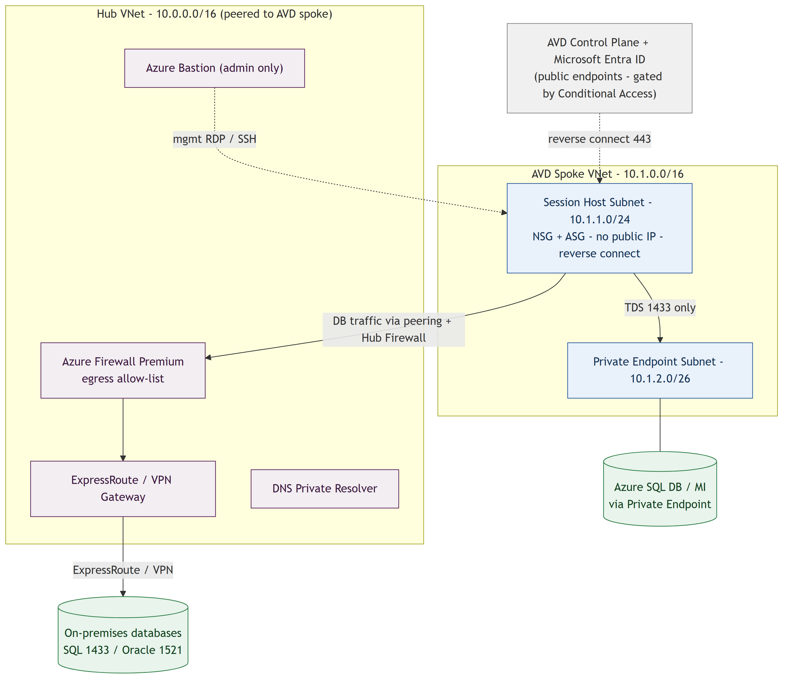

5.2 Subnet and NSG Rule Detail
The session-host subnet (snet-avd-hosts) is associated with nsg-avd-hosts; the private-endpoint subnet (snet-avd-pe) with nsg-avd-pe (subnet network policies enabled so the NSG applies to PE traffic). The exact rules for the session-host NSG are below. Session hosts require no inbound rules — AVD uses reverse-connect (outbound only).

NSG: nsg-avd-hosts-prod-uks (associated with snet-avd-hosts)

Priority | Name | Direction | Source | Destination | Port | Protocol | Action
100 | Allow-AVD-Control-Out | Outbound | snet-avd-hosts | WindowsVirtualDesktop | 443 | TCP | Allow
110 | Allow-AVD-Shortpath-Out | Outbound | snet-avd-hosts | 51.5.0.0/16 | 3478 | UDP | Allow
120 | Allow-Entra-Out | Outbound | snet-avd-hosts | AzureActiveDirectory | 443 | TCP | Allow
130 | Allow-SQL-PE-Out | Outbound | snet-avd-hosts | 10.1.2.0/26 | 1433 | TCP | Allow
140 | Allow-OnPrem-DB-Out | Outbound | snet-avd-hosts | 10.100.0.0/16 | 1433,1521 | TCP | Allow
200 | Allow-Monitor-Out | Outbound | snet-avd-hosts | AzureMonitor | 443 | TCP | Allow
4000 | Deny-Internet-Out | Outbound | snet-avd-hosts | Internet | * | * | Deny
4096 | Deny-All-Inbound | Inbound | * | * | * | * | Deny

5.3 Route Tables (UDRs)
Route Table | Route Name | Address Prefix | Next Hop Type | Next Hop IP | Associated Subnet
rt-avd-hosts-prod-uks | Default-To-Firewall | 0.0.0.0/0 | Virtual Appliance | 10.0.1.4 | snet-avd-hosts
rt-avd-hosts-prod-uks | AVD-ServiceTag-Direct | Service Tag: WindowsVirtualDesktop | Internet | — | snet-avd-hosts
rt-avd-hosts-prod-uks | OnPrem-Via-Firewall | 10.100.0.0/16 | Virtual Appliance | 10.0.1.4 | snet-avd-hosts

5.4 DNS and Private Endpoint Detail
Private Endpoint | Target Resource | Private DNS Zone | FQDN | Subnet
pe-sql-cqc-avd | sql-cqc-avd-prod-uks-01 | privatelink.database.windows.net | sql-cqc-avd-prod-uks-01.privatelink.database.windows.net | snet-avd-pe
pe-kv-cqc-avd | kv-cqc-avd-prod-uks-01 | privatelink.vaultcore.azure.net | kv-cqc-avd-prod-uks-01.privatelink.vaultcore.azure.net | snet-avd-pe
pe-files-cqc-avd | stcqcavdfslogixprod | privatelink.file.core.windows.net | stcqcavdfslogixprod.privatelink.file.core.windows.net | snet-avd-pe

6. Identity, Access and Security Configuration

6.1 RBAC Role Assignments
Scope | Principal | Role Definition | Justification | Assignment Type
App group vddag-cqc-avd-prod-uks-01 | SG-AVD-Vendors | Desktop Virtualization User (1d18fff3-…) | Vendor desktop access | Permanent
rg-cqc-avd-hostpool-prod | SG-AVD-Vendors | Virtual Machine User Login (fb879df8-…) | Sign in to Entra-joined session hosts | Permanent
Subscription (AVD) | AVD autoscale service principal | Desktop Virtualization Power On Off Contributor | Autoscale start/stop of session hosts | Permanent
rg-cqc-avd-* (all) | Platform DevOps service principal | Contributor | IaC deployment pipeline | PIM Eligible
rg-cqc-avd-hostpool-prod | AVD Administrators | Desktop Virtualization Contributor (082f0a83-…) | AVD administration | PIM Eligible

6.2 Managed Identity Configuration
Resource | Identity Type | Identity Name | Granted Roles | Target Resource
vm-cqcavd-prod-uks-0N | System-assigned | (system) | Key Vault Secrets User | kv-cqc-avd-prod-uks-01
VM Image Builder | User-assigned | id-cqc-avd-imgbuilder | Image contributor + gallery publisher | gal_cqc_avd (Compute Gallery)

6.3 Conditional Access Policy Detail
Policy Name | CA-AVD-001 — Block AVD sign-in outside Trusted Vendor IPs
Assignment | Include: SG-AVD-Vendors. Exclude: break-glass / emergency-access accounts
Conditions | Target resources: Azure Virtual Desktop (9cdead84-a844-4324-93f2-b2e6bb768d07) and Windows Cloud Login (270efc09-cd0d-444b-a71f-39af4910ec45). Network: Include Any location; Exclude the trusted named location 'Trusted Vendor IPs'
Grant Controls | Block access
Session Controls | Not applicable

Policy Name | CA-AVD-002 — Require MFA for AVD vendor access
Assignment | Include: SG-AVD-Vendors. Exclude: break-glass accounts
Conditions | Target resources: Azure Virtual Desktop and Windows Cloud Login. No device-compliance requirement (vendors use their own unmanaged devices)
Grant Controls | Require multi-factor authentication
Session Controls | Sign-in frequency 8 hours, matched across both apps

Policy Name | CA-AVD-003 — Session hardening & VM sign-in handling
Assignment | Include: SG-AVD-Vendors. Exclude: break-glass accounts; exclude 'Azure Windows VM Sign-In' from the MFA grant (MFA already satisfied at the gateway)
Conditions | Target resources: Azure Virtual Desktop and Windows Cloud Login. Filter for devices excludes the session hosts from client-compliance evaluation
Grant Controls | Grant with existing session; legacy per-user MFA disabled tenant-wide
Session Controls | Persistent browser session: never; sign-in frequency aligned with CA-AVD-002
The Trusted Vendor IPs named location (Entra ID > Conditional Access > Named locations > IP ranges) contains each vendor's confirmed static public egress IPv4/IPv6 CIDR ranges and is marked as trusted. Vendor sign-in is gated at the identity layer because the AVD gateway is a public Microsoft endpoint. The following policies apply; all exclude break-glass/emergency-access accounts and are piloted in report-only mode before enforcement.

6.4 Key Vault, Secrets and Certificate Configuration
Secret / Key / Cert Name | Type | Purpose | Rotation Policy | Access Via
sql-vendor-cred-<vendor> | Secret | Per-vendor on-premises database SQL login | 90 days | Retrieved in-session / by app
avd-join-cred | Secret | Session-host Microsoft Entra join credential | On rotation | Deployment pipeline
laws-shared-key | Secret | Log Analytics workspace key (agent) | 180 days | Data Collection Rule / AMA

7. Data Design Detail

7.1 Data Access and In-Session Flow
Vendors do not create or own data in this solution; they query existing CQC source databases. This section specifies the profile and session data stores, the database objects vendors access, and retention. No new application data model is introduced.

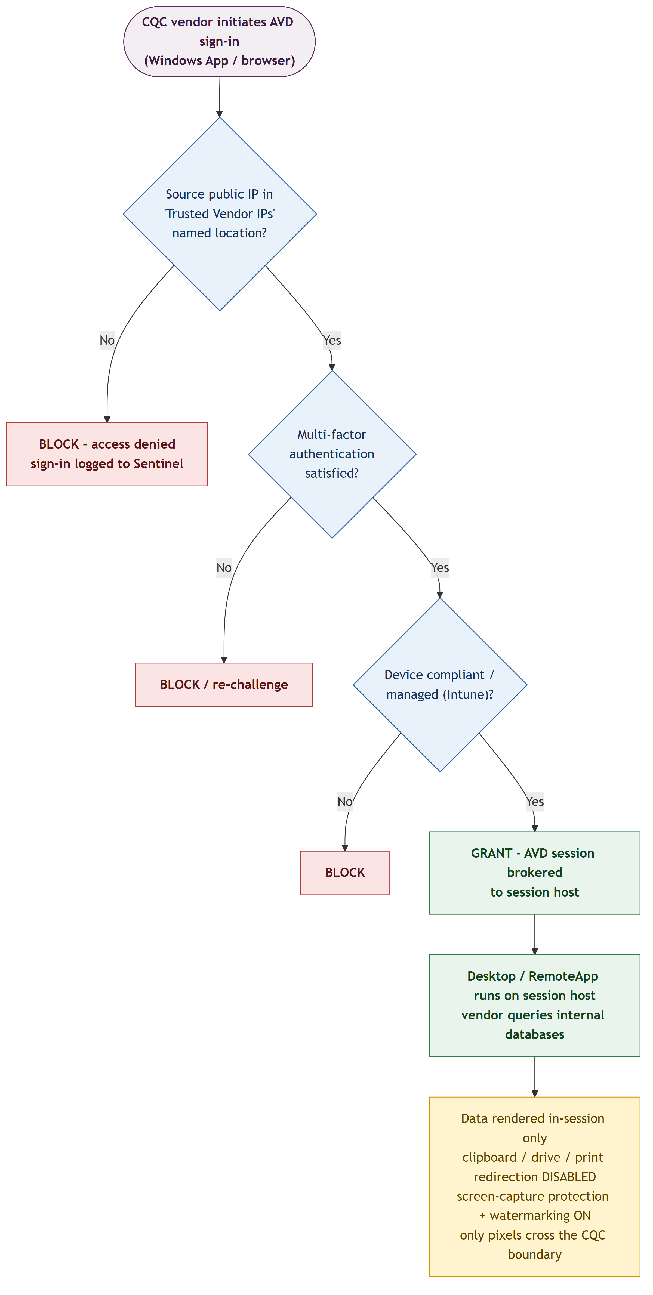

Database | Objects / Schema | Auth Method | Vendor Access
Azure SQL Database / MI (target) | [schemas / views in scope] | Microsoft Entra authentication | Read — least-privilege database role
On-premises SQL Server | [database / schema in scope] | SQL authentication (Key Vault credential) | Read — least-privilege login

7.2 Storage and Profile Definitions
Store | Container / Share | Access | Purpose | Est. Size
Azure Files (Premium) | profiles | Entra Kerberos SMB | FSLogix profile containers | 1 TiB
Log Analytics | log-cqc-avd-prod-uks-01 | Azure RBAC | Diagnostics, session and sign-in logs | ~5 GB/day
Azure Compute Gallery | gal_cqc_avd / vdimg-cqc-avd | Azure RBAC | Golden-image versions | —

7.3 FSLogix Profile Container Configuration
Container Type | VHDX (dynamically expanding), one per user
Storage | Azure Files Premium, Microsoft Entra Kerberos authentication
Redirections | redirections.xml excludes caches and temp; Office container optional
Size Limit | 30 GB per profile; auto-remove orphaned containers on offboarding

7.4 Data Retention, Archival and Purge Jobs
Data Set | Retention Period | Archival Tier | Purge Mechanism | Schedule
FSLogix profiles | While access active | N/A (Premium) | Removed on offboarding | Event-driven
Sign-in logs (Entra) | [e.g. 12 months] | Log Analytics | Retention policy | Continuous
Session / diagnostic logs | [e.g. 90 days] | Log Analytics → archive | Log Analytics retention | Continuous
Golden-image versions | Last N versions | Compute Gallery | Pipeline prune | Monthly

8. Integration and API Design Detail

8.1 Database Connection Specification
Connection | Port | Purpose | Auth | Notes
Azure SQL Database (Private Link) | 1433 | Query target relational data | Microsoft Entra (token) | Redirect mode needs 1433–65535; connect via server.database.windows.net
Azure SQL Managed Instance | 1433 | Query target relational data | Microsoft Entra (token) | Private Endpoint is Proxy on 1433 only
On-premises SQL Server | 1433 | Query internal data | SQL authentication | Via hub firewall over ExpressRoute/VPN
On-premises Oracle | 1521 | Query internal data | Database account | Oracle client delivered on session host

8.2 AVD Control-Plane Egress Endpoints (Firewall Allow-List)
Endpoint / Tag | Port | Protocol | Purpose | Firewall Rule
*.wvd.microsoft.com | 443 | TCP | AVD service traffic incl. TCP-based RDP | App rule (WindowsVirtualDesktop FQDN tag)
login.microsoftonline.com | 443 | TCP | Microsoft Entra ID authentication | App rule (AzureActiveDirectory)
51.5.0.0/16 | 3478 | UDP | RDP Shortpath STUN/TURN | Network rule
*.prod.warm.ingest.monitor.core.windows.net | 443 | TCP | Agent monitoring | App rule (AzureMonitor)
azkms.core.windows.net | 1688 | TCP | Windows activation | Network rule
mrsglobalsteus2prod.blob.core.windows.net | 443 | TCP | Agent / side-by-side stack updates | App rule (Storage)

8.3 Database Authentication Detail
Azure SQL Database / MI | Microsoft Entra authentication (token-based, no stored password). Vendor identities granted least-privilege database roles.
On-premises databases | SQL / database authentication. Per-vendor credentials stored in Azure Key Vault; external identities cannot use Kerberos/NTLM to on-premises.

9. Infrastructure as Code and Deployment

9.1 IaC Repository and Module Structure
Repository | github.com/cqc/avd-vendor-access (or Azure DevOps repo)
IaC Language | Bicep (Conditional Access via Microsoft Graph / Terraform azuread provider)
Module Structure | /modules/network, /modules/avd, /modules/storage, /modules/security, /modules/monitoring
State Management | Bicep deployment stacks; environment parameter files (*.bicepparam)

9.2 Environment Parameter Matrix
Parameter | Dev | Test | Production
Session host SKU | D2as v5 | D4as v5 | D4as v5
Session host count | 1 | 1 | 3 (autoscale 2–6)
Host pool type | Pooled | Pooled | Pooled multi-session
FSLogix storage | Azure Files Standard | Azure Files Premium | Azure Files Premium (Entra Kerberos)
Private Endpoints enabled | No | Yes | Yes

9.3 CI/CD Pipeline Design
Stage | Trigger | Actions | Approval Gate
Validate | PR to main | Bicep lint + what-if; PSRule for Azure | None
Deploy to Dev | Merge to main | Deploy AVD + network; smoke test | None
Image Build | Scheduled monthly | VM Image Builder → Compute Gallery; version | Team Lead
Deploy to Test | Manual | Deploy; validate CA + DB connectivity | Team Lead
Deploy to Production | Manual | Deploy; Session host update; smoke test | Change Advisory Board

9.4 Deployment Sequence
- 1. Deploy networking: AVD spoke VNet, subnets, NSGs, route tables, hub peering, Private DNS zones
- 2. Deploy shared services: Key Vault, Log Analytics workspace, Azure Files Premium (FSLogix, Entra Kerberos)
- 3. Configure Azure Firewall policy (WindowsVirtualDesktop allow-list + DB endpoints) and UDRs on the host subnet
- 4. Build the golden image (VM Image Builder → Azure Compute Gallery) with DB tooling and Defender onboarding
- 5. Deploy host pool, workspace and application groups; deploy Entra-joined session hosts from the image
- 6. Configure RBAC (Desktop Virtualization User + Virtual Machine User Login) for SG-AVD-Vendors; enable SSO
- 7. Apply session-host baseline via Intune/GPO (RDP redirection off, SCP, watermarking, WDAC) and the autoscale scaling plan
- 8. Configure Conditional Access (trusted-IP block + MFA), deploy private endpoints, enable diagnostics/Insights/Sentinel, run validation tests

10. Configuration Management

10.1 Host Pool RDP Properties (Device Redirection Lockdown)
RDP Property | Description | Value | Effect
redirectclipboard:i:0 | Clipboard redirection | 0 | Disabled — no copy/paste out of session
drivestoredirect:s: | Local drive redirection | (empty) | Disabled — no local disks in session
redirectprinters:i:0 | Printer redirection | 0 | Disabled
usbdevicestoredirect:s: | USB device redirection | (empty) | Disabled
redirectcomports:i:0 | COM / serial port redirection | 0 | Disabled
devicestoredirect:s: | MTP/PTP devices (e.g. cameras) | (empty) | Disabled
camerastoredirect:s: | Camera / webcam redirection | (empty) | Disabled
audiocapturemode:i:0 | Microphone capture | 0 | Disabled

10.2 Session Host Security Features
Feature | Purpose | Setting | Applied Via
Screen Capture Protection | Block screenshots and screen-sharing | Block on client and server | Intune / GPO (terminalserver-avd.admx)
Watermarking | Trace leaked screen photos | QR = Connection ID; scale 4, opacity 2000, grid 320×180 | Intune / GPO (AVD admin template)
App Control for Business (WDAC) | Application allow-listing | Enforce; approved DB tools only; block browsers | Intune / device-level policy
Trusted Launch | Boot integrity | Secure Boot + vTPM + VBS | VM configuration
One-way clipboard (optional) | Allow client→host only | Restrict server-to-client transfer | Intune / GPO

10.3 Scaling and Autoscale Rule Configuration
Phase | Schedule | Load Balancing | Min Hosts / % | Capacity Threshold
Ramp-up | 07:00 Mon–Fri | Breadth-first | 1 / 20% | 60%
Peak | 09:00 Mon–Fri | Breadth-first | — | 80%
Ramp-down | 18:00 Mon–Fri | Depth-first | 1 / 10% | 90%
Off-peak | 20:00–07:00 | Depth-first | 0–1 | 90%

11. Monitoring, Logging and Alerting Detail

11.1 Metrics and Diagnostic Settings
Resource | Diagnostic Category | Destination | Retention
Host pool | Checkpoint, Error, Management, Connection, HostRegistration, AgentHealthStatus | Log Analytics (log-cqc-avd) | 90 days
Workspace / App group | Checkpoint, Error, Management, Feed | Log Analytics | 90 days
Session hosts | Windows event logs + performance counters (AMA + DCR) | Log Analytics | 90 days
Key Vault | AuditEvent | Log Analytics | 1 year

11.2 Alert Rule Definitions
Alert Name | Condition | Severity | Action Group
HostPool-NoAvailableHosts | Available session hosts = 0 | Sev 1 | ag-avd-oncall
CA-Block-Spike | Blocked AVD sign-ins from non-trusted IP > threshold | Sev 2 | ag-security
Session-Host-Unhealthy | Agent health status != Available | Sev 2 | ag-avd-oncall
FSLogix-Profile-Failure | Profile attach failures > 0 | Sev 2 | ag-avd-oncall

11.3 Dashboards and Workbooks
Operational Dashboard | Azure Virtual Desktop Insights (log-cqc-avd-prod-uks-01)
SLA Dashboard | Azure Monitor Workbook — host availability and logon times
Security Dashboard | Microsoft Sentinel — vendor sign-in and session monitoring

12. Testing and Validation

12.1 Test Strategy
- Conditional Access validation: confirm sign-in is blocked from a non-trusted IP and permitted from a trusted IP (report-only first)
- MFA enforcement verified for all vendor connections
- Data-exfiltration controls verified: clipboard/drive/print/USB disabled; screenshots blocked (SCP); watermark visible
- Database connectivity verified from the session host (Azure SQL via Private Link; on-prem via ExpressRoute)
- DR / failover test per Section 12.4 (rebuild host pool in UK West from the Compute Gallery image)

12.2 Test Case Summary
Test ID | Description | Type | Expected Result | Status
TC-001 | Sign-in from a non-trusted IP is blocked | Security | Access denied; logged to Sentinel | Not Run
TC-002 | Sign-in from a trusted IP with MFA succeeds | Functional | Session established | Not Run
TC-003 | Clipboard / drive / print redirection disabled | Security | No data egress possible | Not Run
TC-004 | Screenshot blocked (SCP) and watermark visible | Security | Capture blocked; QR watermark shown | Not Run
TC-005 | Azure SQL reachable via Private Link from session | Functional | Query returns; no public route | Not Run
TC-006 | On-prem database reachable over ExpressRoute | Functional | Query returns via hub firewall | Not Run

12.3 Performance and Load Test Targets
Target Concurrent Sessions | [e.g. 25 concurrent]
Logon Time | < 45 s (FSLogix attach + SSO)
RDP Round-trip Latency | < 150 ms; RDP Shortpath (UDP) established
Test Tool | AVD Insights + Login VSI / manual validation

12.4 DR / Failover Test Plan
Test Scenario | Simulate a UK South region outage
Steps | Deploy host pool + hosts in UK West from the Compute Gallery image; fail over the SQL failover group; update DNS
Success Criteria | RTO < 4 hours; profiles restored; database RPO < 5 minutes
Schedule | Annually / before go-live

13. Operational Runbooks

13.1 Deployment Runbook
- 1. Confirm the change request is approved and scheduled
- 2. Verify pipeline variables and Key Vault secrets (join credential, DB credentials) are current
- 3. Run Bicep what-if and review the plan
- 4. Execute deployment via the CI/CD pipeline (network → shared → firewall → image → host pool → hosts → RBAC → CA → PE → monitoring)
- 5. Run post-deployment validation (CA trusted-IP test, MFA, redirection lockdown, DB connectivity)
- 6. Update the deployment log and close the change record

13.2 Rollback Procedure
- 1. Identify the failed deployment via the pipeline or a monitoring alert
- 2. For session hosts: roll back via Session host update or redeploy the last known-good image version from Compute Gallery
- 3. For infrastructure: redeploy the last known-good Bicep version (deployment stack)
- 4. Validate access and database connectivity post-rollback; notify stakeholders and log the incident

13.3 Scaling Procedure
- 1. Review session-host capacity in Azure Virtual Desktop Insights
- 2. For temporary scale: adjust the autoscale scaling plan (max hosts / capacity threshold) with change approval
- 3. For permanent scale: update the IaC host-count parameter and redeploy
- 4. Validate cost impact via Azure Cost Management

13.4 Incident Response and Troubleshooting
Symptom | Likely Cause | Diagnostic Steps | Resolution
Vendor blocked at sign-in | CA trusted-IP policy / wrong egress IP | Entra sign-in logs → CA result and source IP | Confirm the vendor's egress IP is in the named location
Black screen / SSO failure | SSO / Windows Cloud Login misconfiguration | Check remoteDesktopSecurityConfiguration; CA on the 270efc09 app | Enable RDP on the service principal; disable legacy per-user MFA
Database connection fails | Private DNS / redirect port range | nslookup server.database.windows.net from a host; check 1433–65535 | Fix the Private DNS zone link / open the redirect range
Profile fails to load | FSLogix / Entra Kerberos | Check FSLogix logs and storage permissions | Verify Entra Kerberos and SMB RBAC assignments

14. Open Issues and Decisions
The following items require resolution before or during build. Each item must be closed before go-live.

ID | Issue / Decision | Impact | Owner | Due Date | Status
OI-001 | Confirm each vendor's static public egress IP ranges for the Trusted Vendor IPs named location | High | Security Arch | [Date] | Open
OI-002 | On-prem DB authentication — external identities cannot use Kerberos/NTLM; confirm SQL auth vs gMSA/service-broker | High | Data + Security | [Date] | Open
OI-003 | FSLogix for external identities is in preview — confirm supportability or Azure Files Entra Kerberos fallback | Medium | Platform | [Date] | Open

Appendix A -- Configuration and Script Reference
[Insert key CLI, PowerShell, or Bicep snippets used for manual verification or one-off configuration tasks. Example below.]

az deployment group what-if --resource-group rg-cqc-avd-hostpool-prod --template-file avd.bicep --parameters avd.prod.bicepparam

Appendix B -- Glossary
Term | Definition
AVD | Azure Virtual Desktop
ASG | Application Security Group
Bicep | Declarative DSL for deploying Azure resources
CA | Conditional Access (Microsoft Entra ID)
CIDR | Classless Inter-Domain Routing — IP range notation
DCR | Data Collection Rule (Azure Monitor Agent)
DLP | Data Loss Prevention
FQDN | Fully Qualified Domain Name
FSLogix | Profile-container technology for AVD
HLD / LLD | High Level Design / Low Level Design
MI | Managed Identity
NSG | Network Security Group
PE | Private Endpoint
PIM | Privileged Identity Management
RBAC | Role-Based Access Control
RDP | Remote Desktop Protocol
SCP | Screen Capture Protection
Shortpath | RDP Shortpath — optional UDP transport for AVD
SSO | Single Sign-On (Windows Cloud Login)
UDR | User-Defined Route
WDAC | Windows Defender Application Control (App Control for Business)

Appendix C -- Reference Architecture Links
- Azure Architecture Center: https://learn.microsoft.com/en-us/azure/architecture/
- Azure Well-Architected Framework: https://learn.microsoft.com/en-us/azure/well-architected/
- Bicep Documentation: https://learn.microsoft.com/en-us/azure/azure-resource-manager/bicep/
- Azure Resource Naming Convention: https://learn.microsoft.com/en-us/azure/cloud-adoption-framework/ready/azure-best-practices/resource-naming
- Azure Resource Graph Query Reference: https://learn.microsoft.com/en-us/azure/governance/resource-graph/

